What Animals Can Teach Us
About Spirituality
Lessons from Wild and Tame Creatures
by Diana L. Guerrero
Store Name
(ac) phone

Day of week
Date
Time

Pre-order your gift copies today and have them personalized by the author!

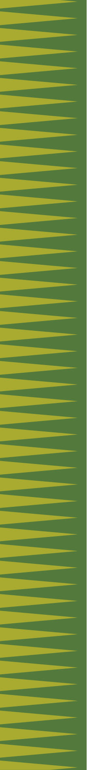
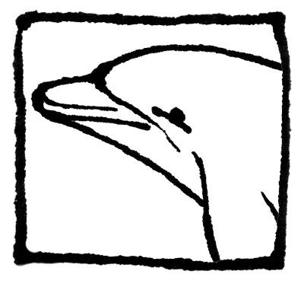
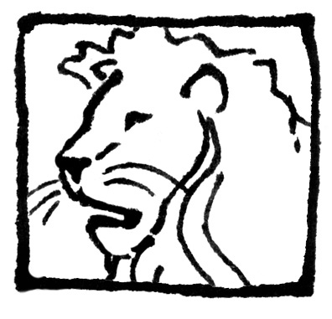
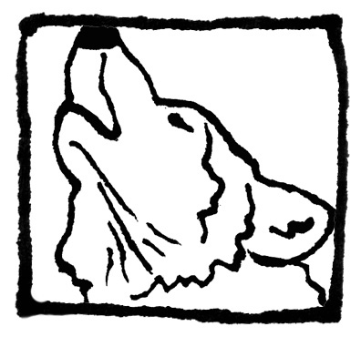
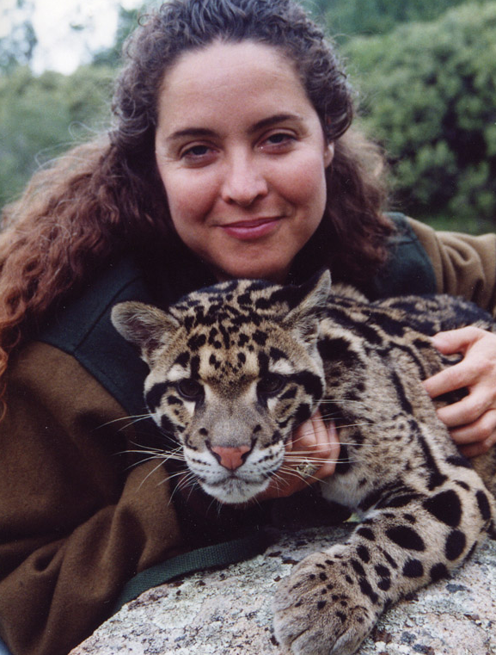


PO Box 1989-215 • Big Bear Lake, California • 92315 USA • 1.800.818.7387 •
Book Event
Meet California Animal Book Author

