What Animals Can Teach Us
About Spirituality
Lessons from Wild and Tame Creatures
by Diana L. Guerrero

Event Location Name
(ac) phone number
Date of Event
Time of Event

Pre-order your gift copies today and have them personalized by the author!
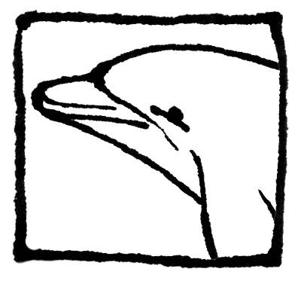
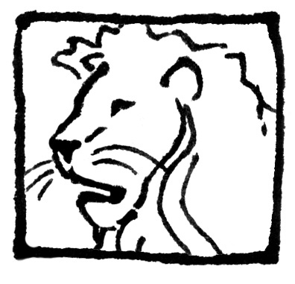
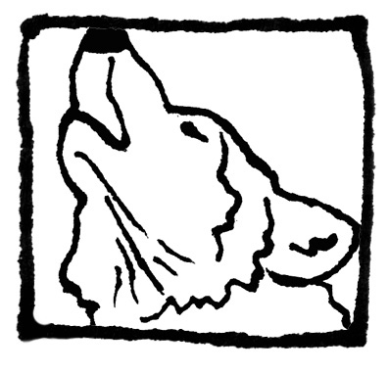
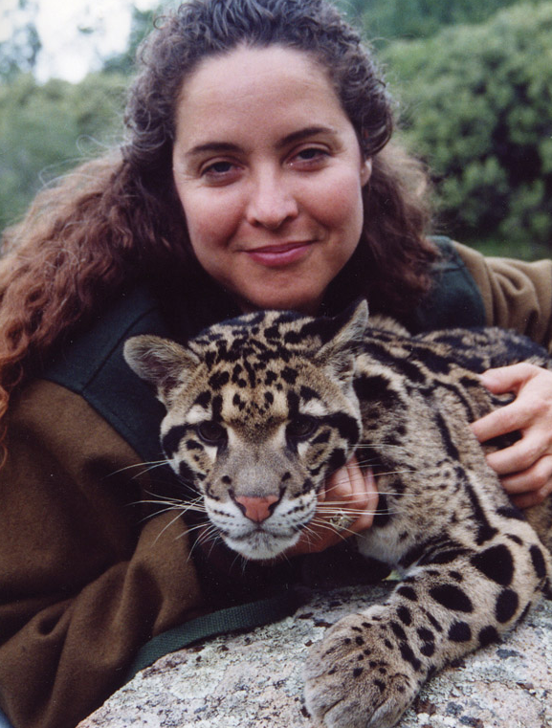

Author Book Event
Meet California Animal Book Author

PO Box 1989-215 • Big Bear Lake, California • 92315 USA • 1.800.818.7387 • book@arkanimals.com

